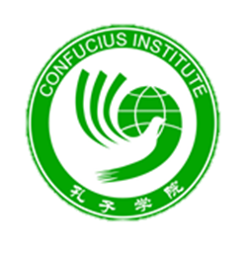
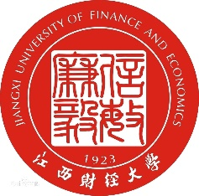

Call for Conference Papers

‘The Belt and Road Initiative: Prospectives, Opportunities and Risks for Business and Development’

Coventry University, UK
20 May 2020

Proposals for papers are invited from Chinese scholars for a major international conference hosted by the Confucius Institute and the School of Humanities at the Coventry University and the Jiangxi University of Finance and Economics (JUFE). The conference is to be held in the historic city of Coventry on Wednesday 20th May, 2020.
The Belt and Road Initiative (BRI) has attracted global attention as a fresh means of driving international sustainable economic growth and development. This conference focuses on the opportunities and risks for business and development. This event provides an important opportunity to gain insights into the aims, operations, potentialities and risks of the BRI. The event explores and assesses the BRI’s drive to build closer connectivity in infrastructure; e-commerce; services; manufacturing; the creative industries; renewable energy; the environment, “ecological civilization”, and the ‘Green BRI”. The event will be of interest to many in the private, public, civil and academic sectors.

Proposals for papers should be a maximum of 250 words in length and address one of the following section themes:

- The Aims and Evolution-Chinese Perspectives
- Opportunities for BRI partners in business and sustainable development
- The China, BRI and the UK
- Risks-What are the risks for business and for sustainable development and how to manage them?
- The Future of the BRI

Within the broad themes, proposed papers should explore the building of closer connectivity. This may include aspects such as infrastructure, financing, legal factors, project management, project contracting, smart business, and e-commerce, services, manufacturing, the creative industries, and the ‘Green” and “Blue” BRI, the role of civil society and the securitization of the BRI.

The central focus through the conference and the various presentations/papers is that of opportunities and risks associated with the BRI. Reference and relevance to the UK and the BRI is welcomed in all papers, but papers are not restricted to this aspect.

The conference organizers are Youfa Liu, Director of the Coventry University Confucius Institute and Professor of Applied Linguistics, Jiangxi University of Finance and Economics and Neil Renwick, Professor in the School of Humanities, Faculty of Arts and Humanities, Coventry University. The conference organizers recognize the logistical and financial support of the Pro-Vice Chancellor International, Professor David Pillsbury, and the Confucius Institute for this conference.

Travel, accommodation and meals for Paper Presenters

Speakers are responsible for the cost of all their travel, accommodation and meals.
The conference will assist in arranging accommodation and will provide the conference lunch and refreshments through the day.

Proposal Submission:

Proposals should include the following information:

- Name of Proposer or proposers
- Title of Proposer(s)
- Institutional affiliation(s)
- Position(s) held (including length of tenure)
- Short biography/biographies (80 words)
- Title of presentation/paper
- Paper outline (250 words)

We ask that papers should be original contributions and not have been previously published. Our aim is to produce an edited book with a recognized international publisher based on the conference papers.

Closing date for proposals: 4.00pm (UK time), 25 February 2020.

Proposals should be sent to:

Professor Youfa Liu at ac4228@coventry.ac.uk and cc’d to Professor Neil Renwick at aa2458@coventry.ac.uk

Accepted papers: an Abstract (150 words); full draft paper of (6,000 words excluding Notes and References) and 15 minute Slide Presentation (Powerpoint format) will be required by 24 April, 2020. Paper format: UK English; Harvard Style; Size 12 Helvetica Font; double-spaced; Notes and References should be at the end of the paper.

We look forward to receiving your proposal.

Professor Youfa Liu
Professor Neil Renwick

